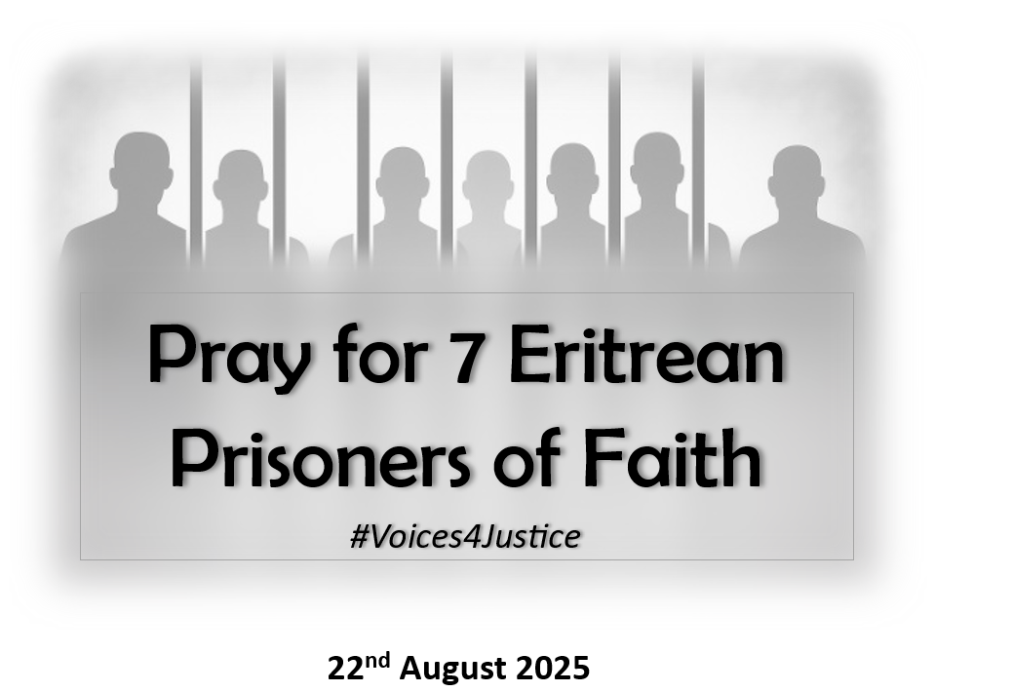

**Prayers for Eritrean Church leaders, Prisoners and Families**

**Dear Friends, do we really understand how powerful our prayers for others can be? Do we really have faith in what they can do?**

**Consider the following words of Frank Laubach from “Prayer the Mightiest Force in the World”:**

*“Thousands of people are being helped by our prayers even when they are beyond the range of our voices…prayers have opened the doors of men’s hearts around the whole world like an invisible love force … If you pray for a man a thousand miles away, his unconscious mind may be attuned outward toward you. …thus, you connect that man with God. That helps God to speak to him directly.”*

**Lord, remind us how vital our prayers are in opening the hearts of others to You, and setting captives free, both spiritually and literally.**

“*Prayer is likely to be undervalued by most people because it is so silent and so secret.*…*So we must guard against expecting easy victory. Prayer is powerful, but it is not the power of a sledge-hammer…It is the power of sun’s rays and raindrops which bless because there are so many of them…Many prayers will show no visible results, but at least some of them will hit the mark… and all of them are necessary. ”*

**Lord, fill our minds with the knowledge of the unseen power of persistent prayer to bring about change and reverse injustice.**

**The Seven:** Today, we focus on the plight of seven Christian leaders in Eritrea who have been detained **indefinitely and incommunicado for at least 20 years,** simply on account of their faith:

**Rev. Haile Naizge**, **detained** since May 2004

**Dr. Kuflu Gebremeskel**, detainedsince May 2004

**Rev Million Gebreselassie**, detainedsince June 2004

**Dr Futsum Gebrenegus,** detained since November 2004

**Rev** **Dr Tekleab Menghisteab,** detained since November 2004

**Rev. Gebremedhin Gebregiorgis**, detained since November 2004

**Rev Kidane Weldou**, detainedsince March 2005.

Imagine being incarcerated without charge or trial,with no release date, and no chance to speak to anyone in the outside world. No letters. No phone calls. No indication of affection. Separated from family and friends, not knowing if you will see them again on this earth. Enduring suffering and pain. Imagine living through that every day for more than 20 years, even to this day.

Yet, the Lord is able to penetrate the deepest darkness and bring their terrible ordeal to an end.

**Pray for these men by name, that they may be assured their plight is not forgotten; that their voices are heard; that their names are remembered; and that people thousands of miles away are praying for them - persistently.**

**Pray that they hold fast to their faith in God, even when everything around them looks hopeless, secure in the knowledge that God is faithful, ‘He remembers his covenant forever, the promise he made, for a thousand generations’ (Psalms 105:8)**

**Ask the Lord who breaks down gates of bronze and cuts through bars of iron to shake the foundations of their prison, open its doors and set them free. (Isaiah 45:2; Acts 16:26)**

**Unnamed Prisoners:** The plight of the seven church leaders is emblematic of the suffering of tens of thousands of unnamed men, women and even children, including around 400 Christians. Eritrea has at least 30 official jails and over 300 unofficial detention centres where torture occurs routinely.Some detainees have died either while in incarceration or soon after being released due to mistreatment, or lack of food and timely medical treatment.

**Pray for the many unnamed prisoners, whose identities are known only to our Heavenly Father. May they be aware that He knows each one of them personally, hears all their pleas, and will answer them.**

**God sees and remembers each person no matter where they are hidden. As David declares in Psalm 139:7-10 ‘Where can I go from your Spirit? Where can I flee from your presence? If I go up to the heavens, you are there; if I make my bed in the depths, you are there… even there your hand will guide me, your right hand will hold me fast’.(Psalm 139:7-10)**

**Pray for prisoners who are ‘in the depths’, enduring unimaginable torture, pain, hunger, illness, fear; that they will be comforted by God’s presence as He promises in Deuteronomy 31:8: ‘He will be with you, He will not leave you or forsake you. Do not fear or be dismayed.’**

**Enforced Disappearance:** Many prisoners were **Forcibly Disappeared** in a manner similar to Revs Gebreselassie and Weldou, who were taken while on the road, driving their cars**.** Their families only know the day and place where they were last seen. With no official notification of arrest, no charge or trial, and, in most cases, no known place of detention, their families suffer continuous agony. Days, weeks, months pass, birthdays, anniversaries, with no sign of them. Families of these victims suffer in painful limbo, sometimes not knowing whether their loved one is still alive.

**Pray for the families of prisoners, who are enduring the unrelenting agony of an enforced and unexplained separation, for God’s loving comfort to engulf them, and for each member to experience Jesus’ promise: ‘My Peace I give you; my peace I leave with you,’ and to be assured that the God of Justice will save them and their loved ones (Isaiah 35:4).**

**One Giant Prison**: It is often remarked that Eritrea is one large prison where the total number of prisoners is unknown and unknowable. There are no official records accessible to the public to identify who is where, for how long any detainee has been or will be incarcerated, or, in many cases, why they have been detained. In 2016 a UN Commission of Inquiry determined Eritrean officials had been committing crimes against humanity since 1991, including religious persecution, and over 30 years later, these crimes are continuing.

**Those in power in Eritrea assume no one can identify the individual victims amongst this unrecorded host and therefore no one can be held accountable; But You, Oh Lord, know the truth, and You have promised that those responsible for their suffering will one day be held to account. ‘Arise O Lord, lift up Your hand. Do not forget the helpless. … Our eyes are on You.’ (Psalm 10: 12 & Chronicles 20:12).**

***‘Then you will call on me and come and pray to me, and I will listen to you.’ (Jeremiah 29:12)***

**Pray in Faith**

**Speak in Love**

**Act in Unity**

***#Voices4Justice***